PPT Basic Questions

1.4 Demand
What is utility?

2. What is meant by demand and what makes it “effective”?

What is the law of demand?

Draw a demand curve for a good such as taxi rides in Beijing. (Don’t worry too much about the exact shape of the curve.)

The demand curve shows the ___________ that _____________ receive from the product.
Consumers on the left/top part of the demand curve have __________ utility from the good and so they will pay a __________ price.
Consumers on the right/bottom part of the demand curve have __________ utility from the good and so they will pay a __________ price.
What is diminishing marginal utility? Give an example.

What are the three reasons why the demand curve slopes downwards?

What happens to the demand curve if there is a change of price?

What happens to the demand curve if there is a change in another factor such as the number of consumers increasing.

By using a graph, illustrate and explain the effect of an increase in income on a normal good and on an inferior good.

Price of oranges increases. Effect on apples?

Demand of golf clubs increases. Effect on golf balls?

Price of cars increase. Effect on public transport use?

Determinants of Demand | Increase | Decrease
Popularity and advertising
Population size
Taste, fashion, season
Interest Rate
Expectations of Price
Incomes (for a normal good)
Price of a substitute
Price of a complement
Show graphically the impact of the following changes on the demand for chocolate boxes:
Consumers’ incomes rise by 20%.

Health studies show that chocolate consumption is bad for our teeth.

1.5 Supply
What is the law of supply?

The supply curve shows the ___________ that _____________ must incur to produce the product.
Units on the left/bottom part of the supply curve have a __________ cost to produce the good and so they will be willing to sell for a __________ price.
Units on the right/top part of the supply curve have a ________ cost of production for the good and so they will only sell for a __________ price.
What effect does a change in price have on the supply of a good?

Give three reasons why producers might increase their supply.

Explain how each of the following might affect the supply curve:
During a bad winter, Britain’s vegetable farmers complain that they cannot harvest their vegetables from the frozen soil.

Cote d’Ivoire, the world’s largest producer and exporter of cocoa, sees an increase in civil unrest which leads to some major highways being closed down.

C) Many governments increase the subsidies they have given to green transport companies.

d) The number of firms in an industry increases.

1.6 Market Equilibrium, Disequilibrium and Changes in Equilibrium
What is meant by equilibrium price?

Use a fully labeled diagram to illustrate equilibrium. Make sure to label the equilibrium quantity Q_{E} and equilibrium price P_{E}

Using the diagram in the example above, calculate the excess demand when the price is set at 50 instead of 100. Show your calculation.
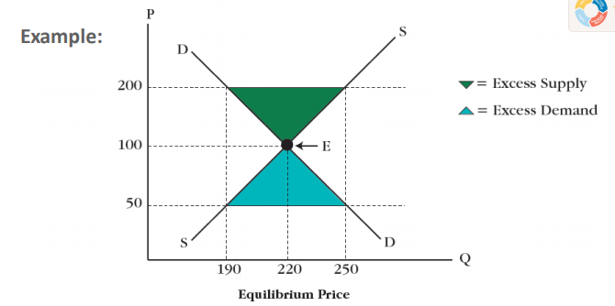
How does the price mechanism interferer to correct excess supply?

Show graphically the impact of the following changes on the demand for chocolate boxes:
Consumers’ incomes rise by 20%.

Health studies show that chocolate consumption is bad for our teeth.

Indicate the new equilibrium position after a subsidy has been given to producers.

What is the double shift rule?

Indicate the new equilibrium position in the market for education after a subsidy has been given to producers and there has been an increase in demand.

A forest fire affects cedar and oak trees which are used to produce wooden barrels. These barrels are also used in the production of expensive wine. What happens to the equilibrium in the market for expensive wine?

A forest fire affects cedar and oak trees which are used to produce wooden barrels. These barrels are also used in the production of expensive wine. What happens to the equilibrium in the market for expensive wine? What is the effect on the market for beer?

